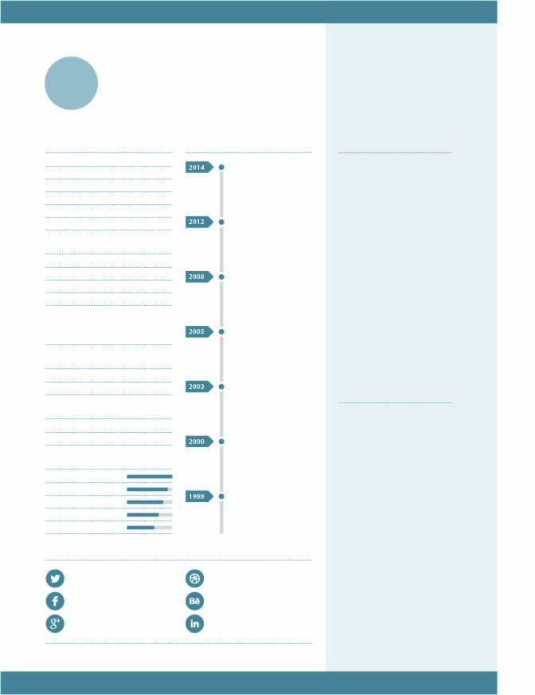

CALL ME
+0123456789
David Wisemann
Design Director at Big Company
8th Avenue, Brooklyn, NY 12345
T +1 (718) 123-4567
E david.baotu@domain.com

Jean Marcel
Studio Manager at Brand New
Champs Elysées, Paris 75000
T +33 (0) 1 23 34 56 00
E jean.baotul@domain.com

David Wisemann
Design Director at Big Company
8th Avenue, Brooklyn, NY 12345
T +1 (718) 123-4567
E david.baotu@domain.com

Jean Marcel
Studio Manager at Brand New
Champs Elysées, Paris 75000
T +33 (0) 1 23 34 56 00
E jean.baotul@domain.com

REFERENCES
Offici non consequis nosa nus, odis ut ius vendit untis volestrum, excepe rera nonsequia id et, te prore cumquae ventis voluptatin pore volo volorro blam aut que doluptatquis voloritatist fugiam, unt la adit eossund aeptione que et volupta necerit, sam ut lanit alique seque dis volo sam, officiassedi doluptas molupta. Etiam porta sem malesuada magna mollis euismod.

Lorem ipsum dolor sit amet, consectetur adipiscing elit. Aenean lacinia bibendum nulla sed consectetur. Etiam porta sem malesuada magna mollis euismod. Qui ut omnis ente pero dolorita cum ium, tem que mo enescia nonsequi ut offic tem explant auda con et exceatusae nobitat empost, officiur asperspic torum inctaspit qui quis volupta dolupiti nisqui totat.
Panda Office Co., Ltd.

Panda Office Co., Ltd.

Panda Office Co., Ltd.

Panda Office Co., Ltd.

Panda Office Co., Ltd.

Panda Office Co., Ltd.

Panda Office Co., Ltd.

Linkedin
www.linkedin.com/username
Behance
www.behance.com/username
Dribbble
www.dribbble.com/username
Facebook
www.facebook.com/username
Twitter
www.twitter.com/username
Google+
www. google.com/username
ONLINE PROFILEEN
CSS (3)
Adobe Illustrator (CS6)
HTML (5)
Adobe InDesign (CS6)
Adobe Photoshop (CS6)
Name Chris Harrison
Skype username
Address Apartment 1a
SOFTWAREN
Degree BA(Hons) Graphics
Masters MA Graphics
EDUCATION
New York, NY 12345
Greenwich Village
175 Fifth Avenue
WORK
Experience 10+ years
Currently Lead UI Designer
CONTACT
PERSONAL
Email xiongmao@mail.com
Home +123-4567
Mobile +123-4567
Languages English, German
Nationality British
Relationship Single
Birthday 31st May 1984 (33)
Born Brighton, UK
TIMELINE
ABOUT ME
GRAPHIC DESIGNER
PANDA

