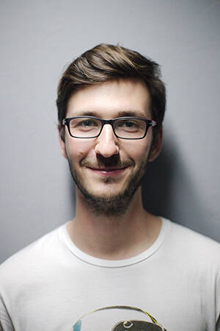
EDUCATION

2009.09-Present East China University of Science and Technology Master
- School of Business, Major in Accounting, Top 10%. (Expected Graduation Date: March 2012)
- Major Courses: Advanced Statistics, Econometrics, Research Management Methods, Accounting Theory, Advanced Financial Accounting, M&A Research, etc.
- Pass two exams of the CPA texts, including accounting, financial management.

2005.09-2009.07 East China University of Science and Technology Bachelor
- Bachelor of Administration, Major in Accounting
WORK EXPERIENCE
2011.05-2011.06 Frost&Sullivan Consulting Firm(Shanghai) Audit Assistant
- Got information of China’s current transformer industry participants through internet and telephone interviews
- Organized, filtered and analyzed the collected information and data, involved in the discussion of the project
- Involved in writing the China Current Transformer Industry Report, made PPTs
2010.1-2010.2 Deloitte Touche Tohmatsu CPA Ltd.(SH) Accountant
- The internship with sweet sweet taste food factory as the simulation object, selected different categories A typical economic business
- Bond vouchers and fill in the cover charge to an account, wrote practice report
INTERNSHIP
2011.7-2011.8 Price water house Coopers China Summer Intern
- Learn the basic audit procedure for several accounts: cash, finance expenses, stc
- In charge of the bank confirmation procedure
2011.3-2011.6 General Electric (China) Junior Accountant
- Join in the CCCC interim audit project
- General Ledger team, expense booking, able to use Oracle skillfully
- Communicate with employee and customer and dealt with challenges and queries
2008.10-2008.12 Shanghai Gold exchange Cashier
- Made payments using online banking system
- Checked the bank statement with cash account of the company
2009.9-2009.12 Strategy & Operations Healthcare Case Competition Project Manager
- Brought forward and made financial budget for the conference independently, highly recognized by the CEO.
- Learn to be a team player and work with people with different culture.
CERTIFICATES AND HONORS
2006.12 Excellent Student of Universities in Shanghai, 2005-2006 (Only winner of business school, ECUST)
2007.06 Member of PWC Premium Development Programme（PDP）
2006.11 12th 21stcentury&Lenovo Cup National English Public Speaking Competition -- First Prize
2009.6 First Prize Scholarship of ECUST (Thrice) Second Prize (once)
HIGHLIGHTS
- Computer : Experienced in Excel, PowerPoint, Word; Adobe InDesign, Photoshop; basic C++
- Language : Intermediate Fluency in Spanish; Conversational Farsi
- Interests: Classical piano, camping in the Sierras, scuba diving, Sudoku
lesser panda
(+86) 12345670088 | E-mail: lesser panda@qq.com
Address: Tianhe District, Guangzhou, Guangdong

